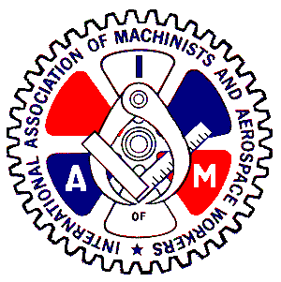
DISTRICT LODGE 26

International Association of Machinists and Aerospace Workers, AFL-CIO

300 State Street STE 506, New London Ste 504-506, Connecticut 06320 / Telephone (860) 554-3003 /
Fax (860) 574-9296
762 Atwood Avenue, Cranston, Rhode Island, 02920 / Telephone (401) 943-8331 / Fax (401) 943-9867

1/6/2025

E-Board and Veterans of Locals within District 26,

We would like to invite you to join us in January 2025 to initiate your disability claims or initiate corrections within the VA system. We will have Richard Evans visiting Local 587, 700, 1746, and 1871 to meet with members. He has experience working with our union members to achieve the benefits that they earned and deserve, with over $2m in backpay for our members. This is a service that is provided to our members and their immediate family at no additional cost. Whether it be initiating a claim or altering a claim, feel free to set up a time to talk to and go over options that you might have.

If you would like to schedule a meeting with him at any of these locals, please contact D26 at 860-554-3003 or email district26sec.t@gmial.com to set up a meeting time and location.

January 27, 2025 Local 1746 East Hartford, CT 9am to 5 pm
January 28, 2025 Local 1871 Groton, CT 9am to 5 pm
January 29, 2025 Local 700 Middletown, CT 9am to 5 pm

More times can be scheduled if the demand is there, including in RI. Please contact the email address to schedule additional time.

Respectfully,
Taylor Salman
D26 Veterans Committee

